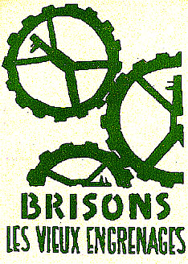

power to the imagination

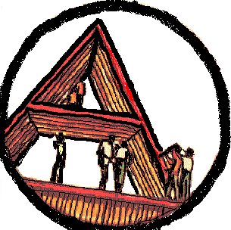

Principles, Propositions & Discussions
for Land & Freedom

'Power to the Imagination! Slogans and graffiti from the Paris, May '68 insurrection'.

"So annihilate forever all that could one day destroy your work."-- Sade

"Those who make revolutions half-way just dig their own graves."-- Saint-Just

Humanity will not be happy until the last bureaucrat is hanged with the guts of the last capitalist.

And what if they burned down the Sorbonne?

Freedom is the crime that includes all crimes.

I take my desires for reality because I believe in the reality of my desires!

Godard: the worst cunt of all the pro-Chinese Swiss!

Professors, you're making us grow old.

Let's be cruel!

Down with the toad of Nazareth!

How can you think freely in the shadow of a steeple?

Consume more, you'll live less.

Down with the abstract! Long live the ephemeral!-- Marxist-Pessimist Youth

Beneath the cobblestones, the beach.

We are all undesirables.

To work now is to work with a gun in your back.

Down with the Stalinist corpse!

Down with the recuperating grouplets!

Comrades, let's lynch Seguy!

The educator must himself be educated.

Militants, liquidation is at hand!

Live without dead time! Enjoy without constraint!

Run fast, comrades, the Old World is behind you!

Boredom is counter-revolutionary.

Never work.

Trade unions are brothels.

I come on the cobblestones.

Neither god nor master!

Smash the state!

Power to the imagination!

